**PYTHON PROGRAMMING TEST -LEANKLOUD**

**TASK 2:**

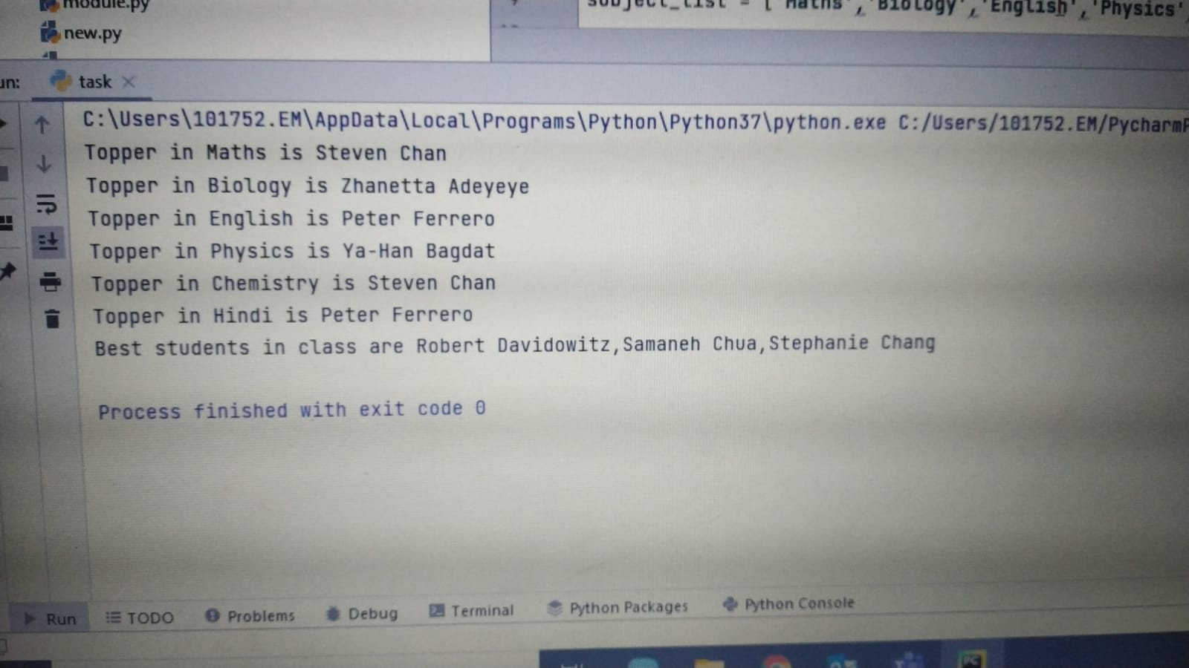

**TASK 1:**

